2018 Admissions Guide
for International Students
Freshman / Transfer

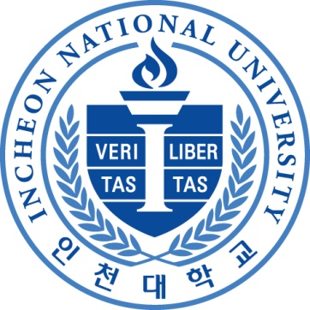

□외국인유학생의효과적인학습및생활을위한지원프로그램
Program to support effective learning and to help international students lead a comfortable life

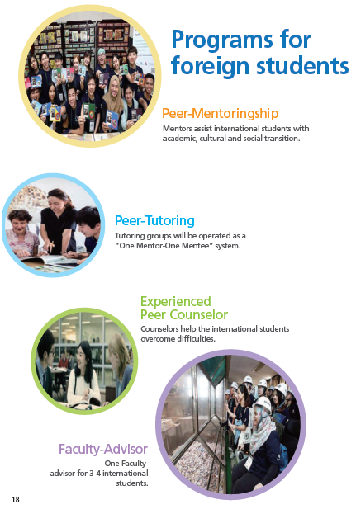

F-버디프로그램:외국인4~5인기준의1명의교내재학생과매칭하여학교생활정착및한국생활전반을도와주는생활멘토-멘티프로그램

F-전공튜터링프로그램:외국인4~5인기준으로기초및전공교과목에대해2명의교내재학생을매칭하여전공학습을도와주는학습멘토-멘티프로그램

F-INU카운셀러프로그램 : 외국인에대한학교생활상담및자신의경험을바탕으로 하여 외국인들의 정신적 문제해결을 도와주는 프로그램

F-담당지도교수:외국인4~5인기준으로학과전공담당교수를정하여, 지속적학교생활관리및면담을통한외국인학생지원프로그램

□외국인유학생의효과적인취업을위한지원프로그램
Support program for effective employment of international students

❍F-진로취업지원프로그램: 외국인유학생의전공및직무를고려한진로지원상담및취업지원프로그램(외국인담당진로취업관배치)
❍ F-Career Employment Support Program :International students have an assigned career consultant

□영어전용국제협력Matrix과정및세계유수대학과의복수학위과정
Matrix College and Dual-degree Program with Prominent Universities
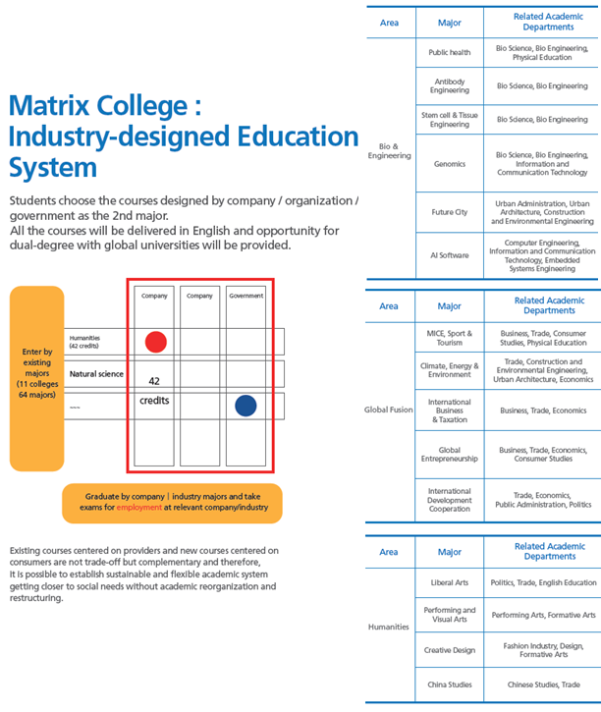
The Institute of Convergence Science & Technology, Incheon National University
- Phone : 82-32-835-9756
- E-mail : inusang@inu.ac.kr

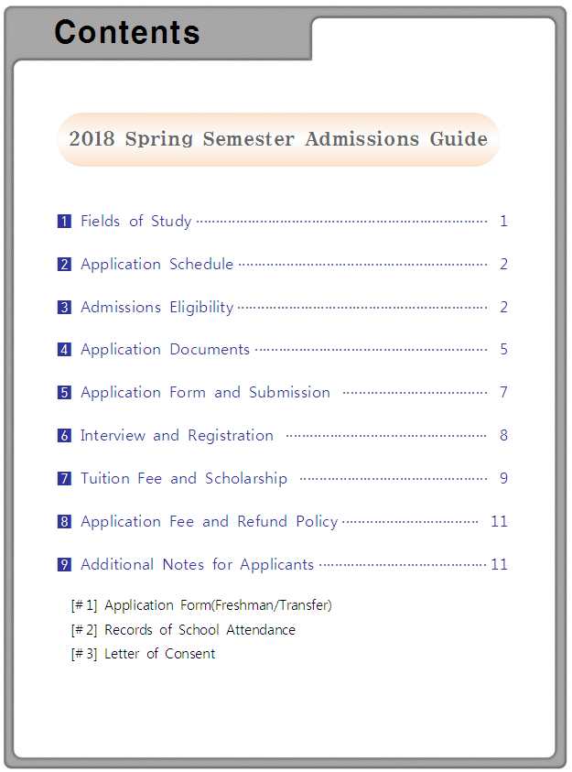

1 |  | Fields of Study

College | Major |  |  | Quota
 |  |  |  | Freshman | Transfer
College of Humanities | Dept. of Korean Language & Literature |  |  | Limited places for each major | Limited places for each major
 | Dept. of English Language & Literature
 | Dept. of German Language & Literature
 | Dept. of French Language & Literature
 | Dept. of Japanese Language & Literature
 | Dept. of Chinese Language & Cultural Studies
College of Natural  Sciences | Dept. of Mathematics
 | Dept. of Physics
 | Dept. of Chemistry
 | Dept. of Consumer & Child Studies
 | Dept. of Fashion & Industry
 | Dept. of Marine Science
College of Social Sciences | Dept. of Social Welfare
 | Dept. of Mass Communication
 | Dept. of Library and Information Science
 | Dept. of Creative Human Resource Development
College of Law,  Politics &  Economics | Dept. of Law
 | Dept. of Public Administration
 | Dept. of Political Science & Int'l Relations
 | Dept. of Economics
 | Division of International Trade
College of Engineering | Dept. of Mechanical Engineering
 | Dept. of Mechatronics Engineering
 | Dept. of Electrical Engineering
 | Dept. of Electronics Engineering
 | Dept. of Industrial and Management Engineering
 | Dept. of Safety Engineering
 | Dept. of Materials Science and Engineering
 | Dept. of Energy and Chemical Engineering
College of Information &  Technology | School of Computer Science and Engineering
 | Dept. of Information and Telecommunication Engineering
 | Dept. of Embedded-Systems Engineering
College of Business  Administration | School of Business Administration
 | Dept. of Tax & Accounting
College of Arts & Physical Education | School of Fine Arts | Korean Painting
 |  | Western Painting
 | Dept. of Performing Arts
 | Division of Sport Science
 | Division of Health and Exercise Science
College of Urban Sciences | Dept. of Urban Policy and Administration
 | School of Construction Environmental Engineering
 | Dept. of Urban Engineering
 | School of Urban Architecture
College of Life Sciences  and Bioengineering | School of Life Sciences
 | School of Bioengineering
 | School of Northeast Asian Studies |  | Korean Trade & Commerce

※Candidates are selected upon review of their academic ability, through a special admissions process for foreign students.
※Candidates applying for majors of fine arts are required to submit portfolios.

2 |  | Application Schedule

Procedure | Date | Notes(Place)
Online Application | November 3, 2017  ~ November 10, 2017 | --Submit online application http://www.inu.ac.kr/  ※ -Admission application is available online ONLY
Document Submission | November 13, 2017 ~ November 20, 2017 | -Submit by post or in person.  (22012) Incheon National University  Admissions Team(Bldg. No.1)  Academy-ro 119, Yeonsu-gu, Incheon, Korea
Interview | November29, 2017(in Korea)  November30, 2017(in China) | -Interview conducted at specified location  -Notice posted on INU website on November24, 2017 (*Application Identification Slip and ARC or Passport are necessary)  ※Video interview will be performed on November 30, 2017.
INU Korean  Proficiency Test | November29, 2017(in Korea)  November30, 2017(in China) | -Pre-Test-application is necessary(Application Form).  -Notice will be posted on our website.  (http://inukli.inu.ac.kr)
Announcement of Admissions | December 15, 2017 | -Notice posted on INU website  ( hhttp://www.inu.ac.kr/  ※Individual notification are NOT provided
Registration  (Tuition Payment) | January 31, 2018  ~ February 2, 2018 | - - Registration Place: INU Designated Bank  ((*Registration Invoice available on "Announcement of Admissions" page.)
Opening | March 02, 2018 | - Each college(department)
※INU Korean Proficiency Test will be held at INU Songdo Campus and other pre-notified overseas institutes. More details will be posted on our website.

3 |  | Admissions Eligibility

3-1. Freshman Applicants

A. Basic Requirements

-High school graduates(or prospective graduates) who have completed public education for more than 12 years can apply for INU International Admissions process with meeting the qualifications of nationality criterion and Korean/English Proficiency standards stated below.(GED or Qualification Examination is not considered as a regular 12-year-course.)

B. Nationality Criterion for International Students

- International students whose parents are BOTH foreign nationals.
- For Taiwanese students, if one of their parents is Korean, will be considered as international students.
※If applicants and(or) their parents have dual citizenships of Korea, they will NOT be considered as international students.

C. Korean Proficiency

- TOPIK(level 3 or above) or a certificate of completing INU Korean Language Institute(level 4 or above) or a result of INU Korean Proficiency Test(level 3 or above).
- Applicants of Korean Language and Literature need a TOPIK level 4 or above.
-Applicants of Korean Trade & Commerce Major need a TOPIK level 4 or above or English Proficiency Qualification stated below.
※TOPIK Level 4 or above is necessary for INU Graduation.
※Overseas Korean and candidates who have previously studied in Korea and/or are fluent in Korean language can submit alternative documentation instead of the Korean Proficiency Certificate.

D. English Proficiency (*only for Freshman Application)

- Korean Trade & Commerce Major: TOEFL(iBT 75), TOEIC(750), IELTS(5.5), PETS(level 4) or above is necessary for application.

3-2. Transfer Applicants

High school graduates(or prospective graduates) who have completed public education for more than 12 years can apply for more than 12 years can apply for INU International Admissions process with meeting the qualifications of nationality criterion and Korean/English Proficiency standards stated below.
* GED or Qualification Examination is not considered as a regular 12-year-course.

A. Nationality Criterion for International Students

- International students whose parents are BOTH foreign nationals
- Taiwanese students, if one of their parents is Korean, will be considered as international students.
※If applicants and(or) their parents have dual citizenships of Korea, will NOT be considered as international students.

B. Korean Proficiency

- TOPIK(level 3 or above) or a certificate of completing INU Korean Language Institute(level 4 or above) or a result of INU Korean Proficiency Test(level 3 or above).
- Applicants of Korean Language and Literature Major need a TOPIK level 4 or above.
- Applicants of Korean Trade & Commerce Major need a TOPIK level 4 or above or English Proficiency Qualification stated below.
※Students with government-funded scholarship or recommended students by principal(dean) of college in partner institutions with INU need a TOPIK level 2 or above.
※TOPIK Level 4 or above is necessary for INU Graduation.
※Overseas Korean and candidates who have previously studied in Korea and/or are fluent in Korean language can submit alternative documentation instead of the Korean Proficiency Certificate.

C. English Proficiency

- Applicants of Korean Trade & Commerce Major : TOEFL(iBT 75), TOEIC(750), IELTS(5.5), PETS(Level 4) or above.
- Applicants of Korean Trade & Commerce Major are selected upon English proficiency only.
※Students with government-funded scholarship or students by recommended principal(dean) of college from a partner institutions with INU need iELTS 5.0 or above.
※Students from country where English is an official language are exempt from this requirement.

D. Academic Requirements

Grade | Eligibility
2nd year | 1) Completed at least 1 full academic year(more than 2 regular semesters) at a 4-year university in Korea or overseas(Summer/Winter session is not included)  ※Applicants from an overseas university must have acquired more than one quarter of the credits required for graduation.(evidential document must be submitted)  2) Equivalent academic background more than junior/community/vocational college., or above  (will be considered under the related laws.)
3rd year | 1) Completed at least 2 full academic years(more than 4 regular semesters) at a 4-year university in Korea or overseas(Summer/Winter session is not included)  ※Applicants from overseas university must acquire more than half of the credits required for graduation. (evidential document must be submitted)  2) Graduated from 2- or 3-year college in Korea or overseas.  3) Equivalent academic background junior/community/vocational college, or above  (will be considered under the related laws.)
※Applicants are able to apply for any majors for international students despite of their previous academic backgrounds.

4 |  | Application Documents
4-1. Freshman
No. | Required Documents | How to Prepare
 |  | Chinese | English |  | Others
1 | ①Application Forms ②Records of School Attendance  ③Letter of Consent for Education Verification
2 | 3-①Highschool Transcript Certificate | Consulate  Legalization | Apostille  or  Consulate  Legalization |  | Apostille  or  Consulate  Legalization
 | 3-②Highschool Graduation Certificate  ※For Chinese Schools Graduates: Credentials Report from the official website,  www.cdgdc.edu.cn | Credentials Report  or Consulate  Legalization
3 | Certificate of Korean Proficiency  - TOPIK level 3 or higher  - Completion of INUKLI Level 4 or higher  - INU Korean Proficiency Test Level 3 or higher | - Certificate of TOPIK level 3 or higher or Certificate of Korean Language Institute at INU should be submitted at least 15 days prior to the beginning of classes.  - Overdue certificate will not be counted as necessary documents for scholarships.  - For Overseas Koreans, certificates are NOT necessary with their proof document.
4 | Family Relation Certificate  ※In case of parents' divorce or death, proof document is necessary. | Birth Certificate or other documents which prove applicant's family relationship. |  | Translated &  Notarized Copy  (In Korean or English)
5 | A Copy of a National ID card(Applicant & Parents)
6 | A Copy of a Passport(Applicant)
7 | A Copy of an Alien Registration Card (Front & Back page, Only for ARC holders)
8 | A Certificate of Entry and Departure record(Only for applicants who live in Korea)
9 | A Bank Balance Certificate (On the name of applicants or parents or spouse)  ※Over USD 20,000 or KRW/CNY equivalent to this amount  (The certificate must be Issued within a month before you apply.)
10 | English Proficiency Certificate (Korean Trade & Commerce Major Applicants Only)
11 | 2 Photos(3㎝×4㎝) (1 on the Application Form, the other enclosed)
12 | Applicants for need-based scholarship submit the documents below to division of student affairs.①Application Form for need-based scholarship(Download available on our website) ②Family relation certificate ③Parents’ employment certificate and income certificate (English)
※Submit the documents below to office of International Affairs to issue visa application number.
- Official Transcript
- Applicant’s bank balance certificate (English)
3. Parents’ proof of employment and certificates of income (English)
4. Family Relation Certificate(Ho Ku Bu)
5. Photo
※Submit the required application documents, including printed copy of online application.

4-2. Transfer
No. | Required Documents | How to Prepare
 |  | Chinese | English |  | Others
1 | ①Application Forms ②Records of School Attendance  ③Letter of Consent for Education Verification
2 | Highschool Graduation Certificate  ※For Chinese highschool Graduates:  Credentials Report from the official website,  www.cdgdc.edu.cn | Credentials Report  or Consulate  Legalization | Apostille  or  Consulate  Legalization |  | Apostille  or  Consulate  Legalization
3 | University/College Transcripts  ※Overall credits are necessary  ※Should be issued within 6 months for overseas Universities/colleges. | Consulate  Legalization | 〃 |  | 〃
 | University/College Graduation(Prospective) Or  Completion(Prospective) Certificates  ※For Chinese Universities/colleges:  Credential Reports from the official website,  www.chsi.com.cn | Credentials Report  or Consulate  Legalization | 〃 |  | 〃
4 | Certificate of Korean Proficiency  - TOPIK level 3 or higher  - Completion of INUKLI Level 4 or higher  - INU Korean Proficiecny Test Level 3 or higher | - Certificate of TOPIK level 3 or higher or Certificate of Korean Language Institute at INU should be submitted at least 15 days prior to the beginning of classes.  - Overdue certificate will not be counted as a necessary documents for scholarships.  - For Overseas Koreans, certificates are NOT necessary with their proof document.
5 | Family Relation Certificate  ※In case of parents' divorce or death, proof document is necessary. | Birth Certificate or other documents which prove applicant's family relationship. |  | Translated &  Notarized Copy  (In Korean or  English)
6 | A Copy of a National ID card(Applicant & Parents)
7 | A Copy of a Passport(Applicant)
8 | A Copy of an Alien Registration Card (Front & Back page, Only for ARC holders)
9 | A Certificate of Entry and Departure Fact(Only for applicants who live in Korea)
10 | A Bank Balance Certificate (On the name of applicants or parents or spouse)  ※Over USD 20,000 or KRW/CNY equivalent to this amount  (The certificate must be Issued within a month before you apply.)
11 | English Proficiency Certificate (Candidates applying for Korean Trade & Commerce Major Applicants should submit English proficiency certificate, instead of Korean proficiency certificate)
12 | 2 Photos(3㎝×4㎝) (1 on the Application Form, the other enclosed)
13 | Applicants for need-based scholarship submit the documents below to division of student affairs.①Application Form for need-based scholarship(Download available on our website) ②Family relation certificate ③Parents’ employment certificate and income certificate (English)
※Submit the documents below to office of International Affairs to issue visa application number.
1. Official Transcript
2. Applicant’s bank balance certificate (English)
3. Parents’ proof of employment and certificates of income (English)
4. Family Relation Certificate(Ho Ku Bu)
5. Photo
※Submit the required application documents, including printed copy of online application.

4-3. Detailed Information for Preparing documents

A. Consulate Legalization
- English-written original documents can be legalized by Korean Embassy/Consulate without translation.
- Other language-written original documents should be translated into Korean or English and notarized. Then, documents need to be legalized from Korean Embassy/Consulate.

B. Apostille
- After translation(English or Korean) and notarization of the original documents, you can apply for Apostille at Ministry of Foreign Affairs.
- China is not a party of Apostille Agreement.

5 |  | Application Form and Submission

A. Instructions on application form

- If applicant presents any false information, fails to submit required application materials or cannot be contacted, the applicant may be withdrawn from admission review.
- When applicant does not comply with INU’s prescribed process and rules, the applicant will be withdrawn.
- Name and resident registration number should be correctly written.
- If applicant has alien registration number, write them down correctly.
- If applicant does not have alien registration number, write as follows.
EXAMPLE | A male(female) student who was born in May 15, 1992
 | ⇩
 | 920515 –5999999(6999999)
- Write down personal information such as high school, address, phone(mobile) number, e-mail address correctly.
- For refund of application fees or tuition fees, write down bank account number correctly.
- Photos(3cm*4cm) taken within 3 months are to be uploaded online and also to be submitted enclosed.
- INU is not responsible for incompletion or mistakes when filling out application form.

B. A Place for Application Form and Required Documents

- Application materials should be submitted in person or by post to the following address:
(22012) Incheon National University
Admissions Team(Bldg. No.1), 101
Academy-ro 119, Yeonsu-gu, Incheon, Korea

6 |  | Interview and Registration

A. Interview
- Documents screening(100%) and interview(100%)
B. Interview Information
- Domestic resident: Interviewed at the Admissions team, Incheon National University(Songdo Campus)
- Overseas resident(China): Interview via video conference held at:
①Yantai University: Qingqual Road 30, Laisan, Yantai, Shandong province, China
②Shandong University: Hongjialu 5, Jinan, Shandong province, China
③YanBian Korean International School: Zhaoyangjia 2728A, Yanji, Jilin, China
④Dalian University of Foreign Languages : No.6 West of Lvshun Road South, Dalian. China
※If you wish to have an interview overseas, please indicate the venue on the application form.
※If few students apply for interview overseas, it can be cancelled.

C. Evaluation
- Interview evaluates knowledge of major, personality and Korean language proficiency.
- Evaluation: A(100), B(90), C(80), D(70), E(60)
D. Selection Criteria
- Students will be selected based on scholastic aptitude and Korean proficiency.
- Disqualification:
1) More than 2 of evaluation level 'E' through the interview
2) Not eligible for studying at INU
3) Not attending to INU Admission Interview
※Official ID such as Alien Registration Card or passport is necessary for your identification.
E. Announcement of Admission
- Notice will be posted on INU website(http://www.inu.ac.kr). (No individual notification provided)
- Students accepted by INU should be fully aware of all the comments from the website.
- Acceptance could be cancelled when tuition fee is not paid within the period.
-Acceptance notification and registration invoice are accessible on INU website.

7 |  | Tuition Fee and Scholarship

A. 2018 Tuition Fee for Korean Course Applicants (based on the Korean proficiency standard)
※Tuition Fee for 2018 below may be subject to change.
College(Dept.) | Entrance Fee | Tuition Fee | Notes
Humanities / Social Sciences | 250,000KRW | 4,880,000KRW | 1. Tuition Deduction will be  different according to TOPIK  Level  2. Enrolled students’ tuition will be based according to GPA.
Natural Science /  Physical Education | 250,000KRW | 5,478,000KRW
Engineering / Arts | 250,000KRW | 6,150,000KRW
•Eligibility for Application : TOPIK level 3 or above

B. 2018 Tuition Fee for English Course Applicants (based on the English proficiency standard)
※Tuition Fee for 2018 below may be subject to change.
College(Dept.) | Entrance Fee | Tuition Fee | Notes
Humanities / Social Sciences | 250,000KRW | 9,824,000KRW | 1. Tuition Deduction will be  different according to iELTS  grades.  2. Enrolled students tuition will be based according to GPA.
Natural Science /  Physical Education | 250,000KRW | 10,476,000KRW
Engineering / Arts | 250,000KRW | 11,200,000KRW

•Tuition Fee for English course : Tuition Fee for Korean course + English course (2,500,000KRW) + International Cooperative Matrix Program (2,500,000KRW)

•Eligibility for Application : iELTS 5.5 or above / high school graduates from English speaking country

C. Need-based Scholarship
•Freshman or transfer students of 2018 Spring semester can apply to need-based scholarship
•80% of admitted students for 2018 spring semester will get over half of scholarship as students’ department(major) scholarship. (Amount of expected scholarship is available by using “Net Price Calculator󰡓on INU website)
•amount of scholarship will be decided based on students’ need and department’s(major’s) standard,. Scholarship can cover all your tuition
•Students should achieve 2.7 GPA or higher
•Required Documents: family relation certificate, parents’proof of employment and income statement

D. Merit-based Scholarship
•Need-based Scholarship will be applied to freshmen or transfer students of 2018 spring semester.
•New International Students(Freshmen/Transfer Students)
Korean Course | TOPIK level 4 or above
English Course | iELTS 6.0 or above
※Applicants who graduated from schools where English is the official language are exempt from scholarship for English course. (Scholarship for Korean course is available.)
•For enrolled students who have achieved 15 credits or more and 3.2 GPA or above on their previous semester, amount of merit-based scholarship will be graded according to their GPA.
•Amount of merit-based scholarship
New International Students(Freshmen/Transfer Students) |  |  |  | Enrolled Students | Amount of Scholarship
TOPIK | iELTS | TOEIC | TOEFL(iBT) | GPA of Last Semester
Level 6 | 7.0 | 800 | 94 | 4.0 or above | 100% of tuition fee
Level 5 | 6.5 | 750 | 87 | 3.6 or above | 85% of tuition fee
Level 4 | 6.0 | 700 | 82 | 3.2 or above | 70% of tuition fee
※ Results from alternative tests will be compared to similar corresponding tests and then considered.
※Students who have registered in 4 or more semesters at INU Korean Language Institute(KLI) or are recommended by agreement with INU KLI will receive 70% of annual tuition funds
※ If a student is selected for both need-based and merit-based scholarship, the student will ONLY be awarded the scholarship of highest value.

Name | Eligibility | iELTS | Amount | Notes
Special Scholarship for International Students | NEW  International Students Only. | 7.0 | 100% of tuition fee | Special scholarship at differential rates according to submitted iELTS certificates within the admissions documentation submission period.
 |  | 6.5 | 70% of tuition fee
 |  | 6.0 | 50% of tuition fee
- Applicants who graduated from school in English speaking country are exempt from scholarship for English course. (Scholarship for Korean course is available.)

8 |  | Application Fee and Refund Policy
A. Application Fee: 50,000 KRW
B. Bank Account: Nonghyup Bank 1325-01-000314 Swift code : NACFKRSE
※Deposit should be done in applicant's name.
C. Refund Policy
①Excess payment: INU will refund the amount that was excessively made.
②Failure to meet your condition of admission: INU will refund the full amount you have paid.
③Failure to meet your condition of admission due to natural disasters: the full amount you have paid.
④Failure to meet your condition of admission due to diseases or accidents(with relevant proof of documentation): the full amount you have paid.
D. Registration Fee Refund
- For refund of registration fee, apply with the official cancellation format INU Admission team.

9 |  | Additional Notes for Applicants

(1) Applicants must submit originals supporting documents. If originals cannot be submitted, copies can be submitted but they must be certified by the Admissions Team at Incheon National University upon submission.
(2) Any documents written in a language other than Korean, English or Chinese must be translated into Korean or English by an accredited translator.
(3) If any information on the application form or other submitted documents are found to be false, or if the applicant uses unfair means to obtain admissions, the application will be automatically withdrawn.
(4) During the background screening process, applicants should cooperate with INU Admissions Team. If students do not comply, acceptance may be cancelled.
(5) If you are found guilty of academic dishonesty (forgery of documentation, cheating, etc.), your offer of admissions will be revoked.
(6) INU reserves the right to seek additional documentation for further check-up.
(7) Submitted forms CANNOT be modified or returned.
(8) Please take care when writing your contact details and not to miss any notifications. Applications may not object if registration or admissions get cancelled due to lack of attention to detail
(9) Personal Information Usage Agreement
- INU reserves the right to use your name/ID number/address/education institutions/contact numbers etc. for Admissions processes, Academic management, Scholarship, Statistics, etc
(10) Students are responsibility to pay all tuition, fees and other associate cost assesses as a result of registration. Registration will be complete when tuition is paid in full within the deadline. Visit the schedule of tuition and fee payment dates.
(11) Medical Insurance for International Students
-All admitted international Students at INU MUST be medically insured and required to submit proof of insurance to of insurance to the INU international Service Center.
- For more details, contact to 032-835-9584
Admission Inquiries
❖Address : (22012)Incheon National University
Admissions Team(Bldg. No.1), 101
Academy-ro 119, Yeonsu-gu, Incheon, Korea
❖Contact : +82+32+835-9276, 9281, Fax. +82+32+858-7141
❖E-mail : admission@inu.ac.kr

Application Form for International Students
2018 Spring Semester (Freshman) |  |  |  |  |  |  |  | Application No. |  |  |  |  |  | ※
Interview  Place | ①Incheon National University ( ) |  |  |  |  |  |  |  |  |  |  |  |  |  |  |  | Color Photo  (3㎝×4㎝)
 | ②YanTai University ( )
 | ③Shandong University ( )
 | ④YanBian Korean International School ( )
 | ⑤Dalian University of Foreign Languages ( )
Department
/Major
Student Information
Name | (Korean) |  |  |  |  | (漢字)
 | (English) (Last Name) |  |  |  |  |  |  |  |  |  |  | (First Name)
Passport Number |  |  |  | Nationality |  |  |  |  |  |  |  |  |  |  | Gender |  |  | M( ) F( )
Date of Birth | (DD/MM/YY) |  |  |  |  |  |  |  | E-mail
Mailing  Address |  |  |  |  |  |  |  |  | Mobile Number
 |  |  |  |  |  |  |  |  | Phone
Family  Information | Full Name |  | (Father) |  |  |  |  |  |  | (Mother)
 | Nationality
 | Phone
 | Address
Academic Information  (High school) | [School Name]
 | [Address]
 | [Phone] [Fax]
 | [Graduation Date] [E-mail]
Korean  Proficiency | ①TOPIK( ) ②Korean Language Course at INU()③INU Korean Language Test( ) ④Exemption( )
English  Proficiency | ①TOEFL( ) ②TOEIC( ) ③IELTS( ) ④PETS( )
Refund  Account | Depositor  Name |  |  |  | Bank |  |  |  |  |  | Account Number
I hereby submit application form. I certify that the information contained in this application is correct and complete.

(DD/MM.YY)

Applicant Name : (Signature)
To the President of Incheon National University
※Applicants are considered to agree the contacts regarding application from INU via e-mail and mobile.
Application Form for International Students
2018 Spring Semester (Transfer) |  |  |  |  |  |  |  |  | Application No. |  |  |  |  |  |  | ※
Interview  Place | ①Incheon National University ( ) |  |  |  |  |  |  |  |  |  |  |  |  |  |  |  |  |  | Color Photo  (3㎝×4㎝)
 | ②YanTai University ( )
 | ③Shandong University ( )
 | ④YanBian Korean International School ( )
 | ⑤Dalian University of Foreign Languages ( )
Department
/Major
Application  Category | ①Sophomore Transfer( ) ②Junior Transfer( )
Name | (Korean) |  |  |  |  |  | (Chinese Letter)
 | (English) (Last name) |  |  |  |  |  |  |  |  |  |  |  |  | (First)
Passport Number |  |  |  |  | Nationality |  |  |  |  |  |  |  |  |  |  |  | Gender |  |  | M( ), F( )
Date of Birth | (DD/MM/YY) |  |  |  |  |  |  |  |  | E-mail
Mailing  Address |  |  |  |  |  |  |  |  |  | Mobile |  |  |  |  | ☏
 |  |  |  |  |  |  |  |  |  | Phone |  |  |  |  | ☎
Family  Information | Full Name |  | (Father) |  |  |  |  |  |  |  | (Mother)
 | Nationality
 | Phome
 | Address
Academic Information  (College,  University) | [School Name]
 | [Address]
 | [Phone] [Fax] [E-mail]
 | Acquired Credits |  |  |  |  |  |  |  |  |  |  | GPA
Korean  Proficiency | ①TOPIK( ) ②Korean Language Course at INU( ) ③INU Korean Language Test( ) ④Exemption( )
English  Proficiency | ①TOEFL( ) ②TOEIC( ) ③IELTS( ) ④PETS()
Refund  Account | Depositor  Name |  |  |  |  | Bank |  |  |  |  |  |  | Account Number
I hereby submit application form. I certify that the information contained in this application is correctand complete.
(DD/MM.YY)

Applicant Name (Signature)

To the President of Incheon National University
※Transfer to Korean Trade&Commerce requires applicants to meet English proficiency standard only.
※Applicants are considered to agree the contacts regarding application from INU via e-mail and mobile.
Records of School Attendance

2018 Spring Semester  (Freshman/Transfer) |  |  | Application No.
Department/Major
you are applying for
Name |  |  |  | Date of Birth

Educational  Background | Name of School | Period | Grade | 1 |  | 2 |  | 3 |  | 4 |  | 5 |  | 6
 |  |  | Semester | 1 | 2 | 1 | 2 | 1 | 2 | 1 | 2 | 1 | 2 | 1 | 2
Elementary School |  | ～ |  |  |  |  |  |  |  | - | - | -
 |  | ～
Secondary School |  | ～
 |  | ～
High School, |  | ～
 |  | ～
College/ University |  | ～
 |  | ～
Educational Background : Elementary, Secondary, High School, College, University

I hereby submit School Information form. I certify that the information contained in this application is correct and complete.

(DD/MM.YY)

Applicant Name (Signature)

Letter of Consent
 | Admissions Team | TEL : (82+32)835-9281, 9276  FAX : (82+32)858-7141  E-mail：admission@inu.ac.kr
 | 119 Academy-Ro, Yeonsu-Gu, Incheon, KOREA 22012
【For Students】
*School Name :*e-Mail :
*Address :
*Zip Code : *Phone : *FAX :
To whom IT may concern :

*has been admitted to the Incheon National University for the Spring Semester of 2018. The documents he(or she) submitted indicate that he(she) previously attended your school. Yet for the sake of the Standard Operational Procedure of the Incheon National University, his(her) documents must be confirmed. Included are his(her) brief personal data along with photocopies of the documents he(she) submitted to us. I would deeply appreciate if you could verify the documents and let us know the results by mail and fax or e-mail above.

I am looking forward to hearing from you soon.
Sincerely yours,
HurJin, Ph.D. (signature)
Dean of Admissions & Student Affairs

Letter of Agreement
I have applied to the Incheon National University in Incheon, Korea for the 2018academic year and have agreed to allow the Incheon National University to officially request verification. In this regard, I would like to ask for your full assistance to the Incheon National University when they contact you regarding the verification of transcripts.

*Date of admission(transfer) : *Date of graduation :
*Student ID Number : *Date of Birth :
*Name : (signature)
=======================================================
【For School】
Verification Report
￭Above records & transcripts : Correct □, Incorrect □
￭Additional comments :
￭Verifier(Title & Name)(Signature)

